Using the Resilience plug-in
This plug-in to EwE version 6.5 and newer computes resilience (Arreguín-Sánchez 2014) when Ecosim runs, allows users to explore this data in a graph, and saves this data to CSV file when explicitly activated.

Configuration
To show the Resilience form, navigate to Ecosim > Output > Resilience file (Figure 1). The plug-in user interface is then activated. Note that the plug-in will run Ecosim if this has not already been done.
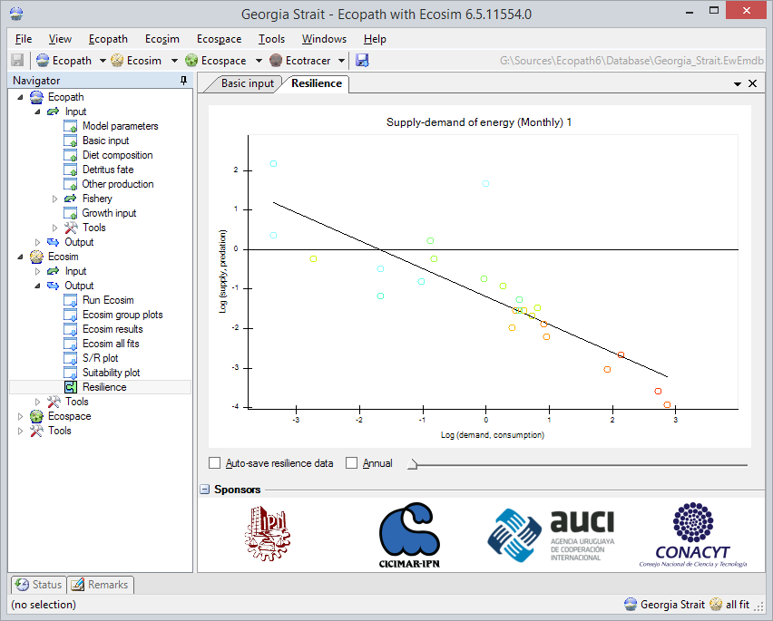
Figure 1 - Activating automatic saving of Ecosim consumption matrices
The Resilience graph is revealed, displaying either monthly or annual resilience trends for the different consumers in the Ecopath model. The time slider can be used to display resilience for different Ecosim time steps (when showing monthly data) or years (when showing annual data).
Note that the graph is scaled to the maximum supply and demand values (either monthly or annual) across the Ecosim run.

Auto-saving
The Resilience user interface contains the option to turn auto-saving on or off (see Figure 1). This option can also be toggled from the EwE file management settings (Tools > Options > File Management, Figure 2)
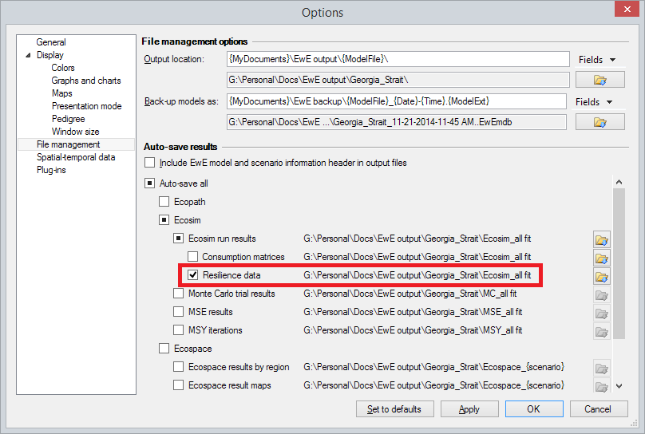
Figure 2 - Activating the resilience auto-save option
Whenever this option is active during an Ecosim run resilience CSV files will be saved to the path indicated in the auto-save settings for every time step, and for annual average values. The EwE Status panel will inform the user that resilience data has been saved, and where (Figure 3). Underlined nodes in this panel can be clicked to open the folder that data was saved to.
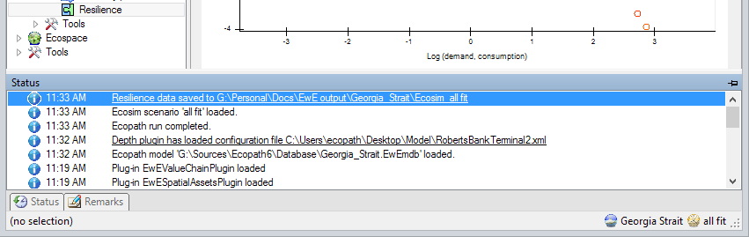
Figure 3 - The status panel provides information where data has been saved
CSV files will be named “Resilience_monthly.csv” and “Resilience_annual.csv”. CSV files are formatted just like any other CSV file produced by Ecosim.

Details to be aware of
The plug-in adheres to EwE-wide export settings:
- Numbers will be formatted according to US English notations, with decimal points and without thousands separators;
- CSV files will be comma separated;
- CSV files will include the EwE model and scenario header unless this functionality is explicitly turned off in the auto-save settings (see Figure 1)

References
Arreguín-Sánchez, F. (2014). Measuring resilience in aquatic trophic networks from supply–demand-of-energy relationships. Ecological Modelling 272, 271–276.

